PARKING APP USING IMAGE PROCESSING

By S.Priyadharshini,S.Rameshwer,S.Rohith

Easwari Engineering College,Ramapuram,Chennai-89

Abstract

This paper aims to present an intelligent system for parking space detection based on image processing technique that capture and process the brown rounded image drawn at parking lot and produce the information of the empty car parking spaces. It will be display at the display unit that consists of seven segments in real time. The seven segments display shows the number of current available parking lots in the parking area. This proposed system, has been developed in software and hardware platform. Index Terms—intelligent parking, parking space detection, image processing.

INTRODUCTION

Currently, most of the existing car parks do not have a systematic system. Most of them are manually managed and a little inefficient. The problem that always occurs at the car park is time being wasted in searching for the available parking spaces. Users will keep on circling the parking area until they found an empty parking spot. This problem usually occurs in urban areas, where number of vehicles is higher as compared to the availability of parking spaces. These ineffective conditions happened because of the lack of implementation in technologies which are available in the market today. Various systems have been done to ensure smoothness of traffic in car park areas. From manual implementations used in the old systems, they have evolved into fully automated, computerized systems. Car park entrances are controlled by barrier gates whereby parking tickets are used extensively for access purpose. With the growth of technology, these systems have been simplified in many ways. Nowadays, there are many methods used in detecting the parking cars in parking lots. In this project, a camera is used as a sensor for video image detection. This is due to its capability and realization cost . The similar project that used camera for video image detection was presented in . This project applies the edge detection with boundaries condition method for image detecting module while in point detection with canny operator method. There are some techniques for making reference image found in the literatures . This project uses a moving car as a reference image to detect the parking lot. Here, the subtraction technique between consecutive images as a method to detect Manuscript. The paper tracks the moving object for the whole area of the door parking lots as a method to count the cars and uses the change of the variance of brightness on the road surface in the stationary image (difference between consecutive frames). The time differential images as a method to extract moving objects from stationary objects. However, the moving object is often taken as many regions (called moving regions) in the differential images . The problem occurs when the object is moving in high speed. It is difficult to capture its movement. Thus in this paper, the parking lot detection is done by identify the brown rounded image drawn at each parking lot. MATLAB is used as software platform in this project. In part II, the detail description of system initialization, image acquisition, image segmentation and image detection as a system module will be presented. Part III presents the experimental results then part IV is conclusion and suggestion for future works to make this project more efficient.

SYSTEM MODULE

Our project consists of five modules. The first module is system initialization as a procedure to automatically identify location of every parking lot in the image. The second is image acquisition module, which involves capturing and storing digital images taken from video camera. A car park scene is the input acquired by this module. This acquisition device is connected to a processing unit that runs in MATLAB program. The third module is image segmentation, which separate the objects from the background and differentiate the pixels having nearby values for improving the contrast . The thresholding technique as a popular tool in the image segmentation is also used. The fourth module is image enhancement. In this module, the noise is removing by using morphology functions, which remove pixels that do not belong to the objects of interest. The boundary of objects in image is tracing which is concentrated on the exterior boundaries. The last module is image detection, which is used to determine the rounded brown image drawn at each the parking lot. The overall module is illustrated in Fig. 1. The details of each module are described below:

IMAGE ACQUISATION

IMAGE SEGMENTATION

IMAGE INITIALIZATION

IMAGE DETECTION

IMAGE ENHANCEMENT

System module.

System Initialization

The module runs only for the first time when this system is started. A one-time manual drawing procedure is performed where a rounded brown image drawn at each park (with zero car present in the car park area), as in Fig. 2. A rounded brown image is drawn on each parking lot manually. The purpose of this procedure is to automatically identify location of every parking lot in the image. It should be noted that the lines separating the parking lots have to be visible, clear and unobstructed in the initialization process. The camera is assumed to be in a fixed position and facing a fixed direction all the time. The initialization process will begin with the program searching for the rounded brown image by detecting the shape of the image. Detected image are then analysis to determined available parking lot.

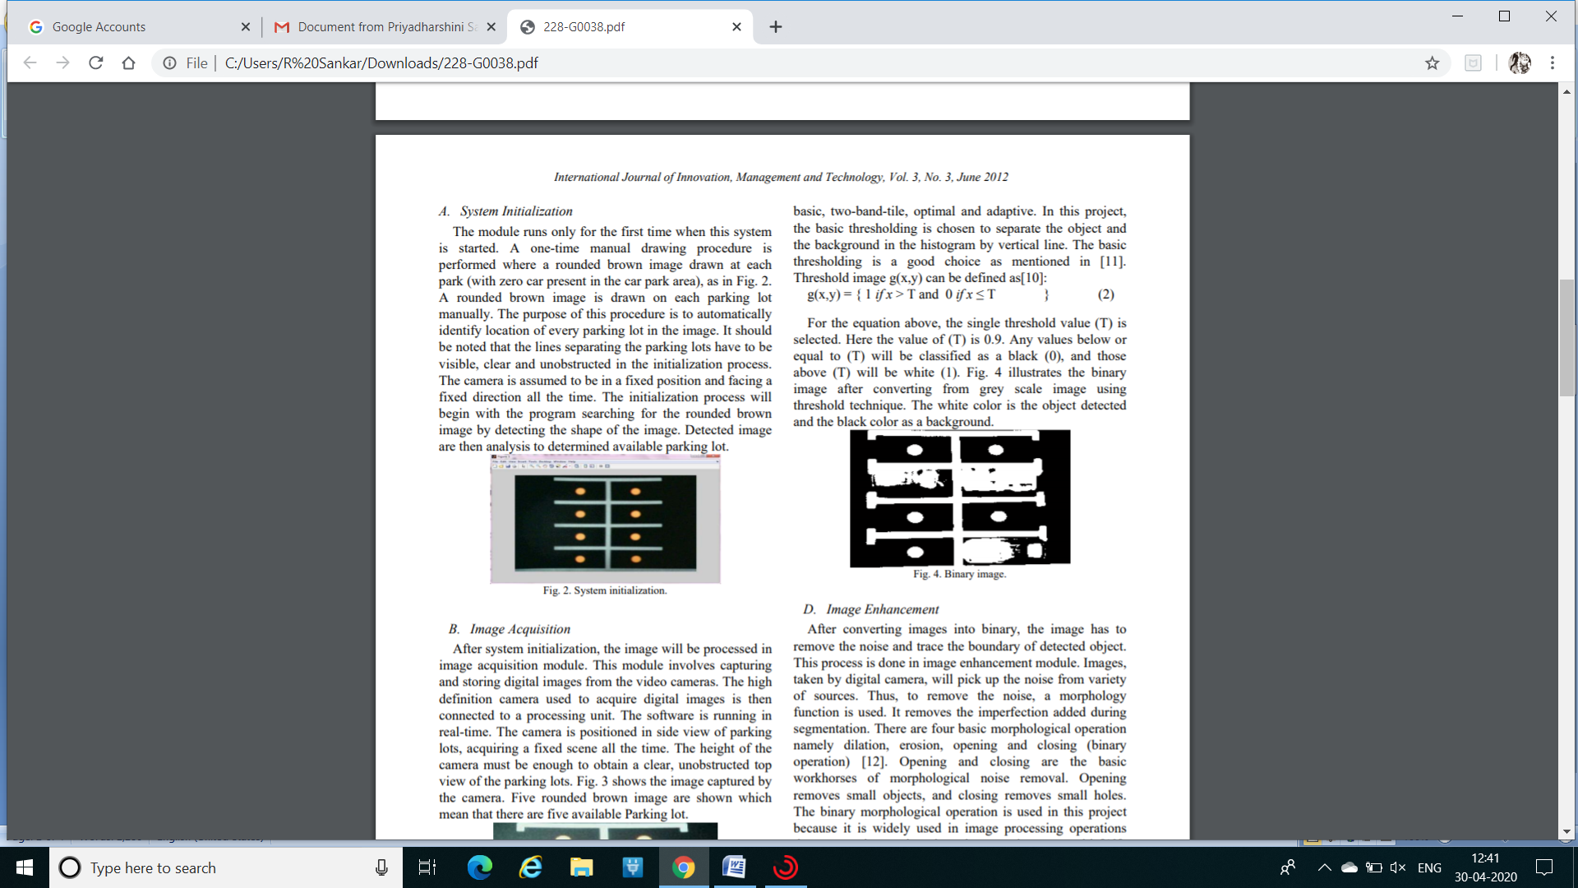

Image Acquisition

After system initialization, the image will be processed in image acquisition module. This module involves capturing and storing digital images from the video cameras. The high definition camera used to acquire digital images is then connected to a processing unit. The software is running in real-time. The camera is positioned in side view of parking lots, acquiring a fixed scene all the time. The height of the camera must be enough to obtain a clear, unobstructed top view of the parking lots. Fig. 3 shows the image captured by the camera. Five rounded brown image are shown which mean that there are five available Parking lot. Fig. 3. Image capture from camera.

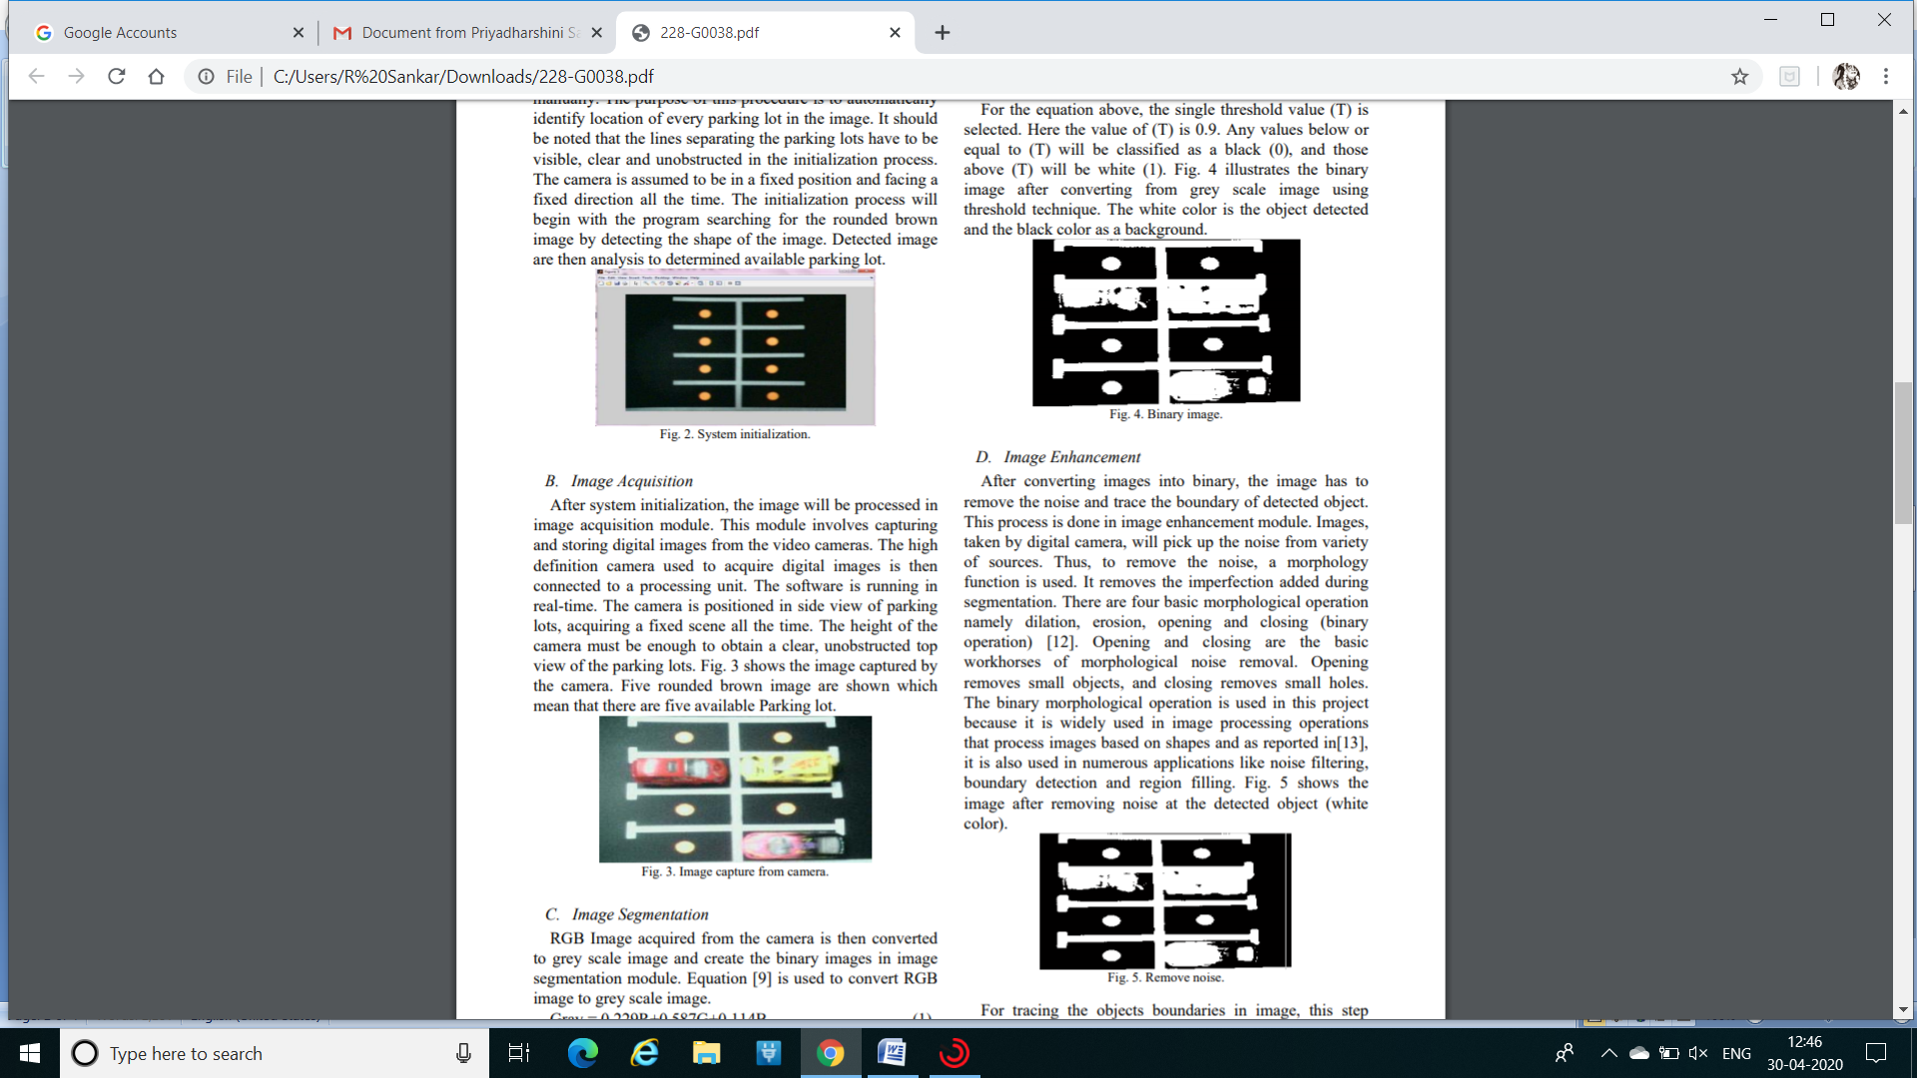

Image Segmentation

RGB Image acquired from the camera is then converted to grey scale image and create the binary images in image segmentation module. Equation is used to convert RGB image to grey scale image. From the gray scale image resulted, thresholding technique can be used to create the binary image. The binary images contain all of the essential information about the position and shape of the objects of interest (foreground). It reduces the complexity of the data and simplifies the process of recognition and classification as an advantage . There are several types of thresholding method like basic, two-band-tile, optimal and adaptive. In this project, the basic thresholding is chosen to separate the object and the background in the histogram by vertical line. The basic thresholding is a good choice. Threshold image g(x,y) can be defined as[10]: For the equation above, the single threshold value (T) is selected. Here the value of (T) is 0.9. Any values below or equal to (T) will be classified as a black (0), and those above (T) will be white (1). Fig. 4 illustrates the binary image after converting from grey scale image using threshold technique. The white color is the object detected and the black color as a background.



Image Enhancement

After converting images into binary, the image has to remove the noise and trace the boundary of detected object. This process is done in image enhancement module. Images, taken by digital camera, will pick up the noise from variety of sources. Thus, to remove the noise, a morphology function is used. It removes the imperfection added during segmentation. There are four basic morphological operation namely dilation, erosion, opening and closing (binary operation) . Opening and closing are the basic workhorses of morphological noise removal. Opening removes small objects, and closing removes small holes. The binary morphological operation is used in this project because it is widely used in image processing operations that process images based on shapes, it is also used in numerous applications like noise filtering, boundary detection and region filling. the image after removing noise at the detected object (white color).



For tracing the objects boundaries in image, this step concentrates only on the exterior boundaries. Dilation and erosion is used in this stage. Dilation adds pixels to the boundaries of object in image. The value of the output pixel is the maximum value of all the pixels in the input pixel’s neighborhood. Erosion will removes pixel on object boundaries. The value of the output pixel is the minimum value of all the pixels in input pixels neighborhood. In a binary image, if any of the pixels is set to 0, the output pixel 233 International Journal of Innovation, Management and Technology, Vol. 3, No. 3, June 2012 Gray = 0.229R+0.587G+0.114B (1) g(x,y) = { 1 if x > T and 0 if x ≤ T } (2) is set to 0. Fig. 6 shows the image after tracing the object boundaries. As we can see, the hole is added by the pixels in dilation process and the unwanted pixel is removed by erosion process.Tracing object boundaries.

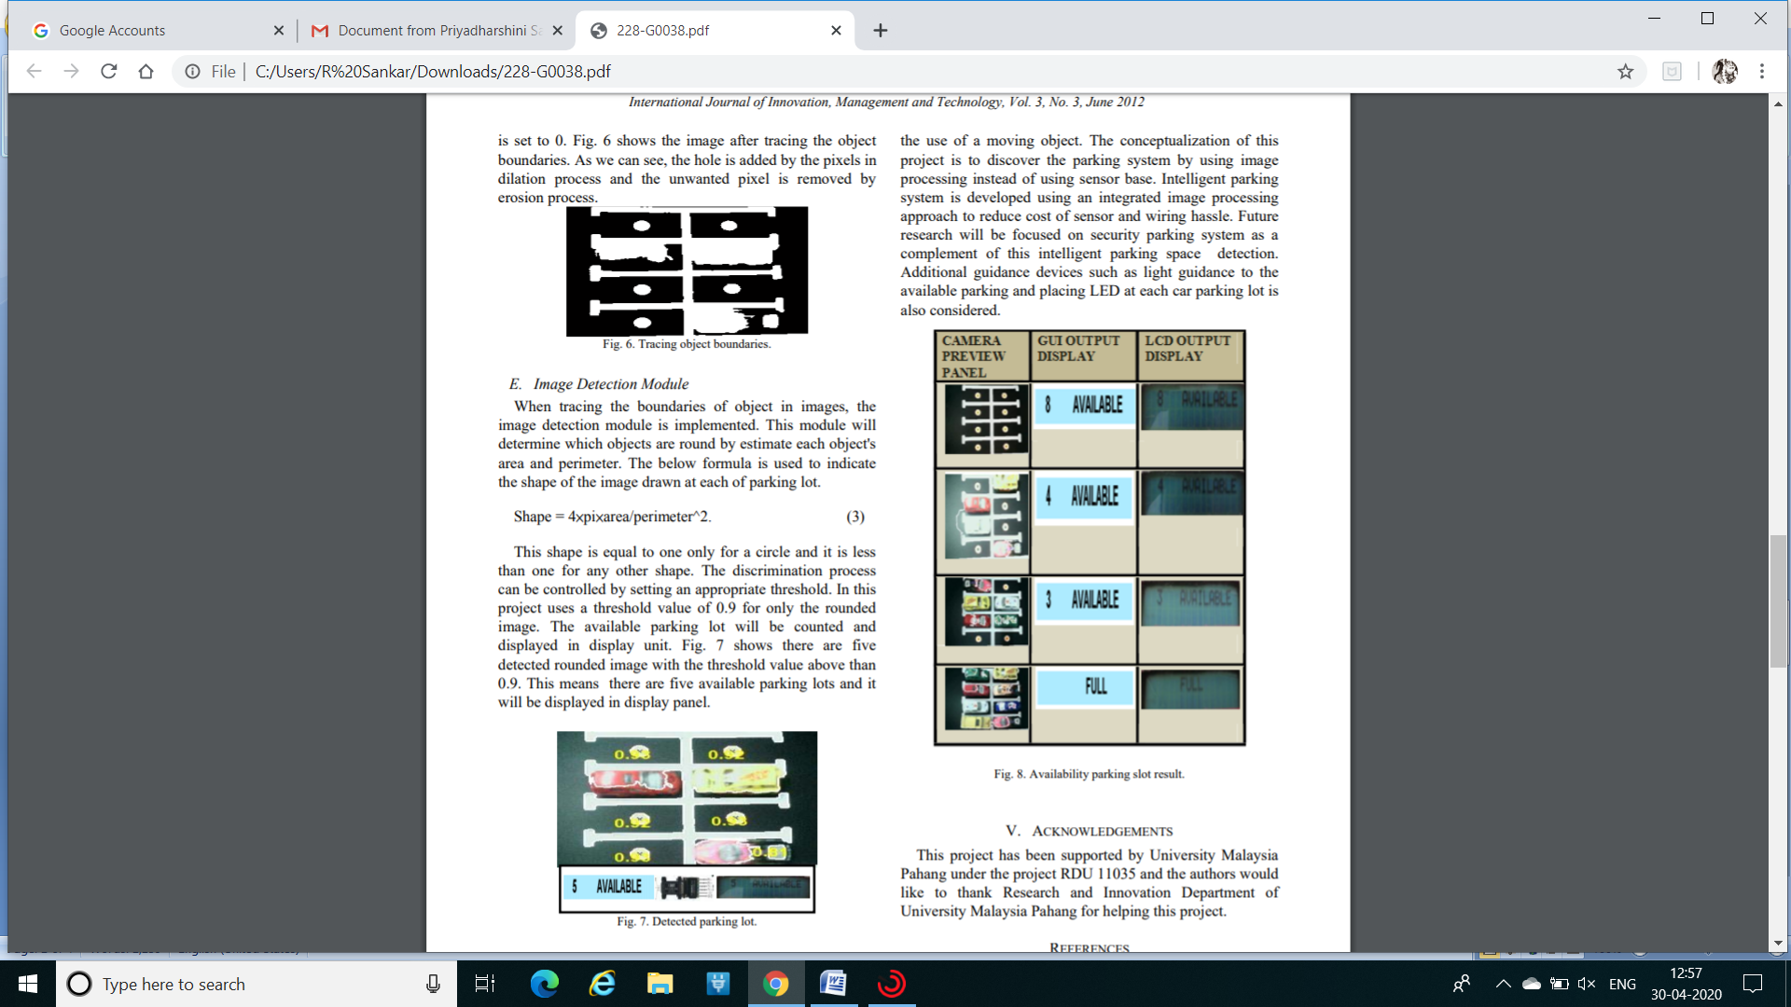

Image Detection Module

When tracing the boundaries of object in images, the image detection module is implemented. This module will determine which objects are round by estimate each object's area and perimeter. The below formula is used to indicate the shape of the image drawn at each of parking lot. This shape is equal to one only for a circle and it is less than one for any other shape. The discrimination process can be controlled by setting an appropriate threshold. In this project uses a threshold value of 0.9 for only the rounded image. The available parking lot will be counted and displayed in display unit. Fig. 7 shows there are five detected rounded image with the threshold value above than 0.9. This means there are five available parking lots and it will be displayed in display panel.



APP DEVELOPMENT

Once the slot is made available then the customer can select one of the free slots according to their convinenece.Once a slot is booked by the customer then the way to the specific slot is displayed to the specific customer and for others the slot appears to be blocked.This mechanism is achieved by Google maps by GUI technique and platform is done by tensor flow and python.

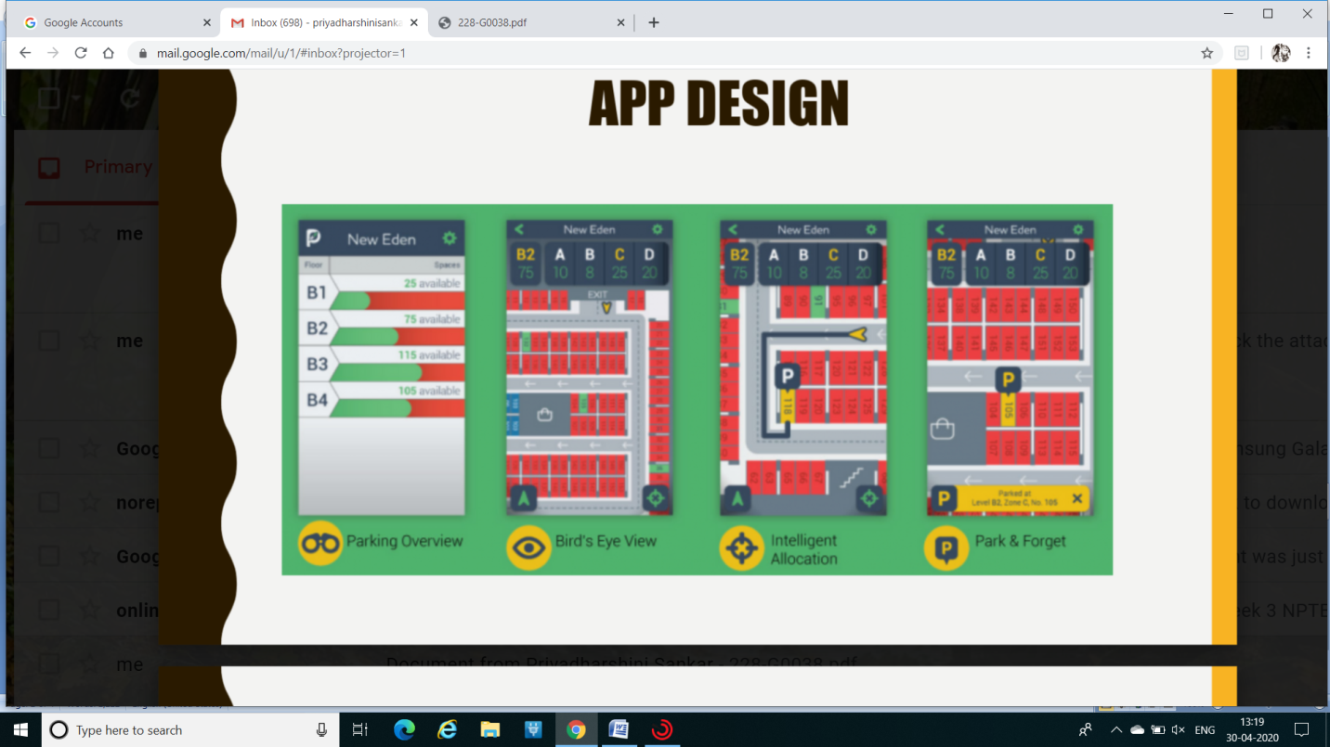

EXPERIMENTAL RESULT

An intelligent parking lot detection system based on image processing have been tested and proposed in this paper. This results are included the sequences of the car park detection from empty lot until the full parking lot.

CONCLUSION AND FUTURE WORK

The intelligent parking space detection system based on image processing was designed and tested. By identify the rounded brown image drawn at each parking lot as a reference on image detection, it makes the process of detecting image as a reference more efficient compared to the use of a moving object. The conceptualization of this project is to discover the parking system by using image processing instead of using sensor base. Intelligent parking system is developed using an integrated image processing approach to reduce cost of sensor and wiring hassle. Future research will be focused on security parking system as a complement of this intelligent parking space detection. Additional guidance devices such as light guidance to the available parking and placing LED at each car parking lot is also considered. Availability parking slot result.

REFERENCES

Z. Bin, J. Dalin, W. Fang, and W. Tingting, A design of parking space detector based on video image, The Ninth International Conference On Electronic Measurement &Instruments ICEMI 2009. [2] K. Ueda, I. Horiba, K. Ikeda, H. Onodera, and S. Ozawa, (1991). An algorithm for detecting parking cars by the use of picture processing (1981), IEICE Trans. Information and Systems.vol.J74-D-I1. IO, pp. 1379-1389.

T. Hasegawa and S. Ozawa, “Counting cars by tracking of moving object in the outdoor parking,” Vehicle Navigation and Information Systems Conference 1994, pp 63-68.

E. Maeda and K. Ishii(1992), “Evaluation of normalized principal component features in object detection,” IEICE Trans. Information and Systems. vol.J75-D-11(3):520-529.

M. Yachida, M. Asada, and S. Tsuji. Automatic Analysis of Moving Image. IEEE Trans. Pattern Anal and Mach.Intell. vol.PAM1-3(1) pp.12-19.

Ms .Sayanti Banerjee, Ms. Pallavi Choudekar and Prof. M. K. Muju. “Real time car parking system using image processing,” 2011. IEEE, pp. 99-103.

S. Arora, J. Acharya, A. Verma, Prasanta, and K. Panigrahi. “Multilevel thresholding for image segmentation through a fast 235 International Journal of Innovation, Management and Technology, Vol. 3, No. 3, June 2012 statistical recursive algorithm,” Elsevier 2007.Pattern recognition letters 29 (2008).pp. 119-125.

L.Wang and J. Bai. Threshold Selection by Clustering Grey Levels of Boundary. Elsevier Science. Pattern recognition letters 24. pp. 1983–1999

Thiang, Andre Teguh Guntoro, and Resmana Lim, “Type of vehicle recognition using template matching method,” International conference on Electrical, Electronics, Communication, Information 2001. March 7-8.

S. Saleh Al-Amri, N. V. Kalyankar, and Khamitkar S, “Image segmentation by using thershold techniques,” Journal of Computing. vol 2, Issue 5. MAY 2010, ISSN 2151-9617. Per Christian Henden, “Exercise in computer: a comparison of thresholding methods,” NTNU–20Nov 2004.

M Rama Bai, Dr V Venkata Krishna, and J SreeDevi, “A new morphological approach for noise removal edge detection,” IJCSI International Journal of Computer Science Issues. vol.7 Issue 6, Nov 2010.

S. Singh, “Morphological image processing,” A Seminar Report, University Of Science amd Technology Kochi, October 2010.